Linear modeling and feature analysis
We initially focused on LASSO for feature selection but then branched out to try Elastic Net, Ridge, and PLS.
The MAEs for the dimensionality-reduction methods were very close, with LASSO’s being the best followed closely by Elastic Net.
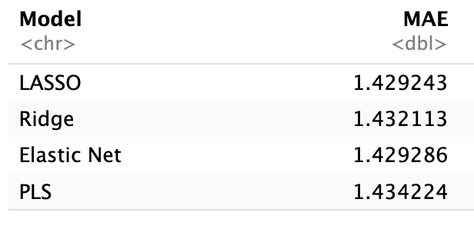
We were curious to see if the same features were prioritized across dimensionality reduction models. Because Ridge and PLS perform regularization and weight shrinkage based on coefficient manipulation instead of feature elimination, we compared the top 20 highest weight features assigned by each for this comparison.
As expected, LASSO, Elastic Net, and Ridge shared many similar features. The top 20 prioritized features selected by Partial Least Squares (PLS), on the other hand, were not seen in any of the other models. This suggests the PLS components may offer unique insight based on feature transformation. PLS constructs components from combinations of variables, so its notion of feature importance is not directly comparable to models that select features based on individual performance. While none of the top 20 features contributing to the six selected PLS components overlapped with the other models, this likely reflects a difference in how importance is distributed across combinations of variables rather than individual predictors.

Top features shared by LASSO, Elastic Net, and Ridge
f111, f218, f221, f313, f383, f384, f398, f413, f471, f526, f533, f536, f615, f663, f673, f674, f775, and f80

Features selected by LASSO alone
f113, f145, f199, f300, f720

Top PLS features prioritized by weight
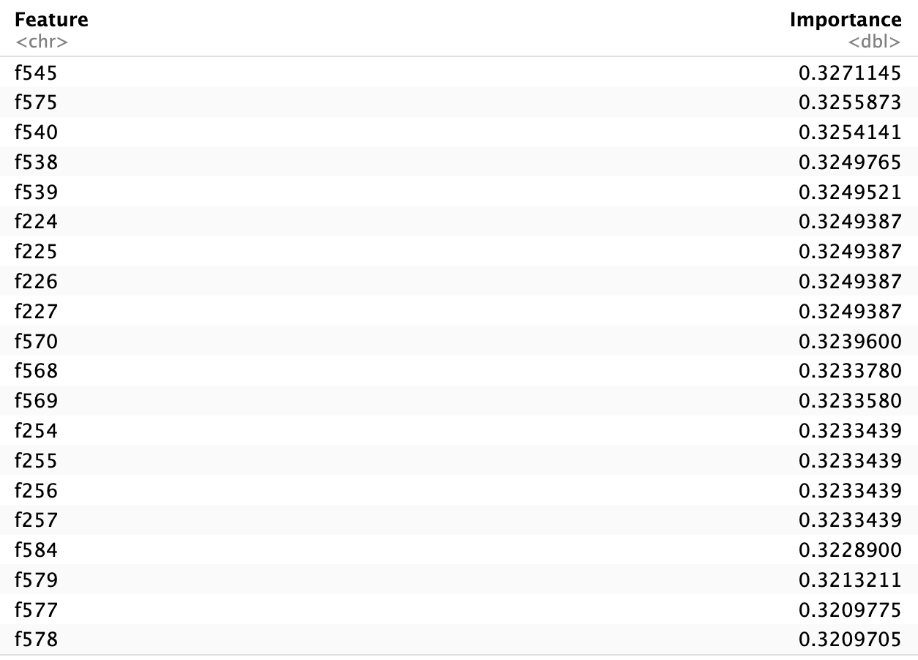

Top PLS components and the features transformed
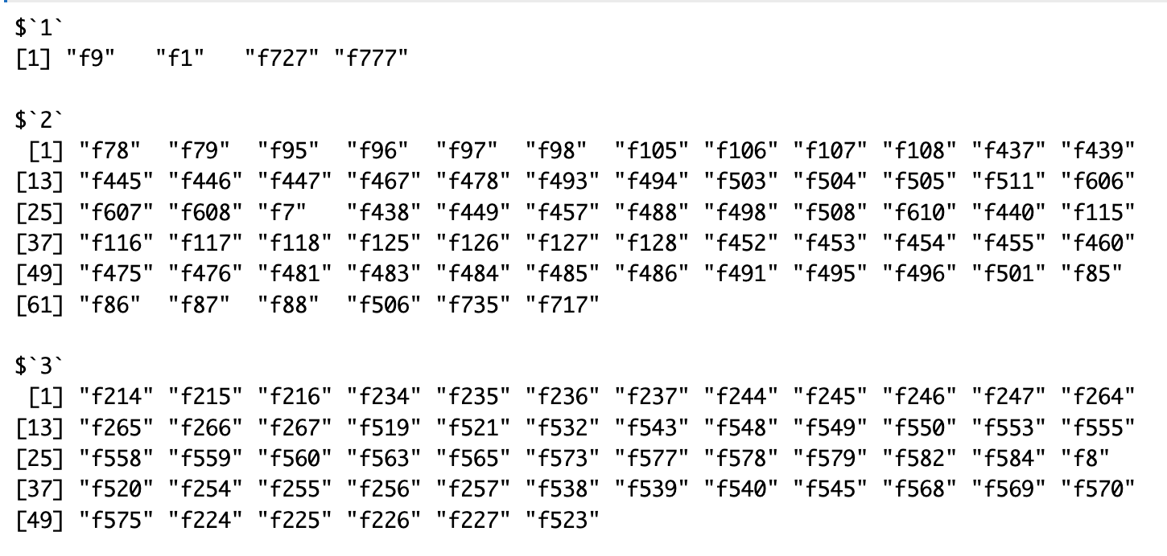

We considered it may be worthwhile to apply ensemble predictive analytics to both the LASSO and PLS manipulated data sets independently. They could both reveal important insight.

